Carbon Reduction Plan
Supplier name: Newcastle upon Tyne Hospitals NHS Foundation Trust
Publication date: 26 September 2025

Commitment to achieving Net Zero

Newcastle Hospitals is proud to be the first healthcare organisation in the world to declare a climate emergency and acknowledge the associated risk to patient health.
In 2020, we published a 5-year Climate Emergency Strategy which included the following vision and goals:

Our Vision
To be a global leader in sustainable healthcare delivery through collaboration and innovation, helping our patients and communities to thrive within the means of our planet

Our Goals
To achieve our vision we have set three long-term goals:
1. Zero Carbon Care
• By 2030 the emissions we control will be net zero – our ‘Newcastle Hospitals Carbon Footprint’
• By 2040 the emissions we can influence will be net zero – our ‘Newcastle Hospitals Carbon Footprint Plus’
2. Clean Air
• By 2030 our operational transport activities generate no harmful air pollution
• By 2040 our healthcare facilities are accessed by only zero emission travel
3. Zero Waste
• By 2030 we will reuse and repair everything that can be reused and repaired
• By 2040 we will produce no waste. We will manage resources within the circular economy, with items surplus to requirements becoming a resource in another part of the system

These carbon targets are ahead of the NHS targets as set out in the Health and Care Act 2022 and Delivering a Net Zero National Health Service report.

In 2021, we were the first healthcare organisation to become a signatory to the UNFCC Race to Zero.

Baseline Emissions Footprint
Baseline emissions are a record of the greenhouse gases that have been produced in the past. Baseline emissions are the reference point against which emissions reduction can be measured. Under the Greenhouse Gas (GHG) Protocol, a base year is a fixed historical point in time for which a company has verifiable greenhouse gas emissions data, against which its current and future emissions are compared to track progress toward reduction targets. Entities must select their base year from the earliest point with reliable data.

Baseline Year: April 2019 – March 2020
Additional Details relating to the Baseline Emissions calculations.
We have adopted an operational control approach to setting the Carbon Footprint boundary and use the SmartCarbon Calculator to measure and report our carbon performance annually. The platform uses the UK Government Carbon Emission factors and supplementary healthcare specific factors, as well as a comprehensive supply chain hybrid approach. This methodology is in line with the NHS Net Zero Plan, The GHG Protocol Corporate Accounting and Reporting Standard, The Greenhouse Gas Protocol Corporate Value Chain (Scope 3) Accounting and Reporting Standard and technical guidance, as well as complying with the Streamlined Energy and Reporting Regulations (SECR).

Scope 1 and 2 emissions below include associated scope 3 emissions (WTT, T+D etc)

Please see our Annual Reports and Full Carbon Footprint reports for more details.

Baseline year emissions: April 2019 – March 2020
EMISSIONS | TOTAL (tCO₂e)
Scope 1 | 59,784
Scope 2 | 4,933
Scope 3  (Included Sources) | 191,674 (4. Upstream transportation and distribution 5. Waste generated in operations 6. Business travel 7. Employee commuting 9. Downstream transportation and distribution)
NHS Carbon Footprint (see Fig. 1 below) | 67,939
Total Emissions NHS Carbon Footprint Plus (see Fig. 1) | 256,391

Current Emissions Reporting

Reporting Year: April 2024 – March 2025
EMISSIONS | TOTAL (tCO₂e)
Scope 1 | 51,797
Scope 2 | 5,146
Scope 3  (Included Sources) | 797,646 (4. Upstream transportation and distribution 5. Waste generated in operations 6. Business travel 7. Employee commuting 9. Downstream transportation and distribution)
NHS Carbon Footprint (see Figure 1) | 59,788
Total Emissions NHS Carbon Footprint Plus (see Figure 1) | 854,589

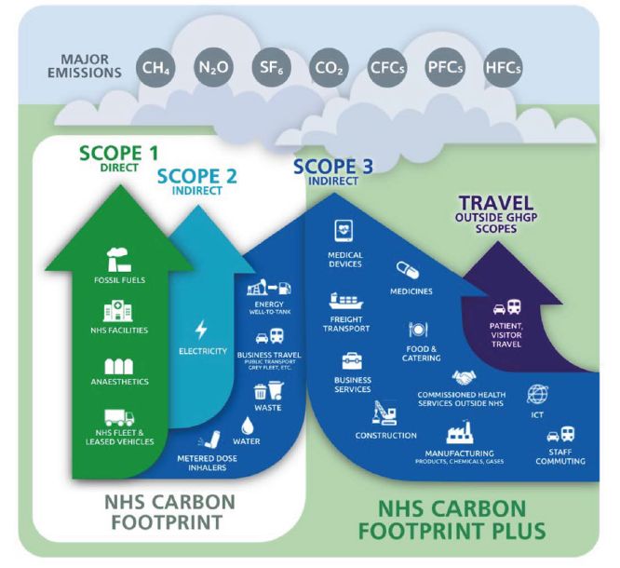
Figure 1. Greenhouse Gas Protocol scopes in the context of the NHS

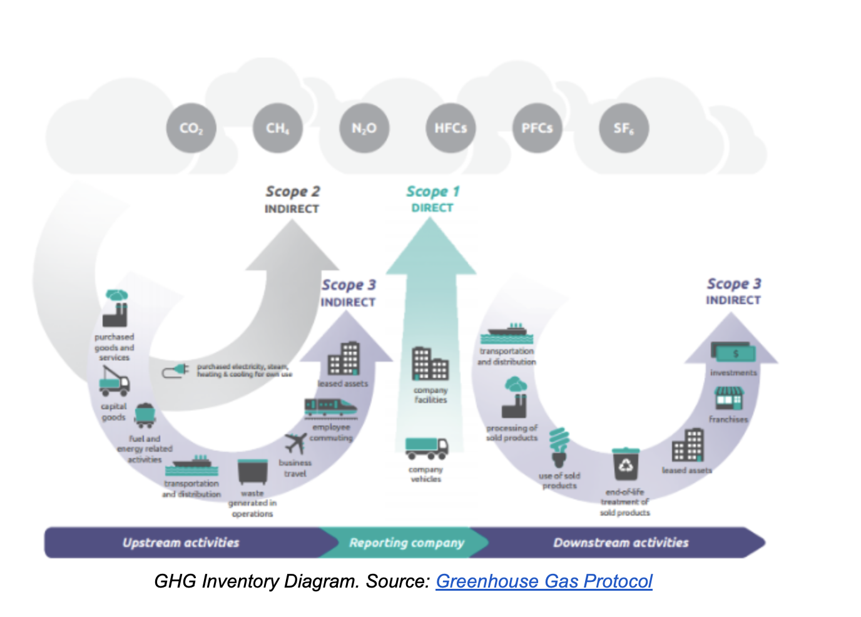

Emissions Reduction Targets

In order to achieve our science aligned Net Zero target our NHS Carbon Footprint will need to decrease over the next five years to 6,793.9 tCO₂e by 2030. This is a reduction of 90%. This is dependent on us decommissioning our on-site fossil fuel combined heat and power energy centres and obtaining the external funding needed to replace these with renewable heat and power.

Progress against our NHS Carbon Footprint 2030 target can be seen in the graph below:

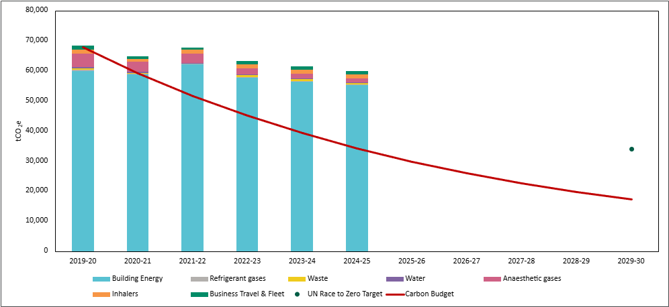

We have also set a reduction target for our NHS Carbon Footprint Plus of 90% by 2040. This will be quantified in tCO₂e when we have calculated an accurate baseline.
Our carbon emissions including our scope 3 NHS Carbon Footprint Plus can be seen in the graph below. We will need to recalculate our baseline in light of more accurate direct data received from suppliers for the first time this year (see note):

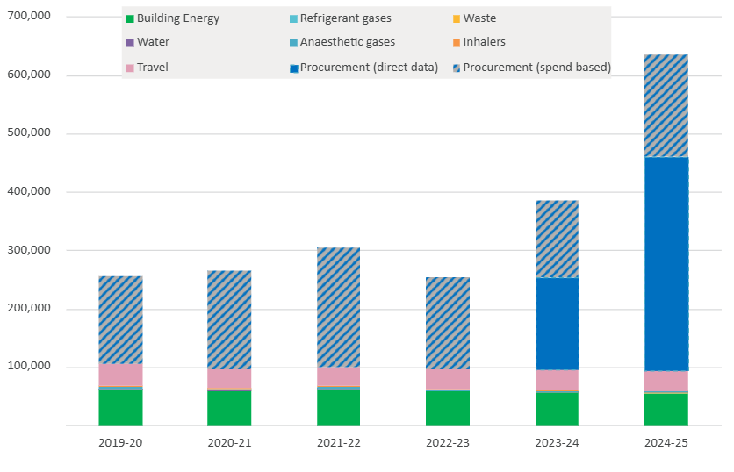

Please see our annual Shine Reports for further detail.

Carbon Reduction Projects

Completed Carbon Reduction Initiatives
The following environmental management measures and projects have been completed or implemented since the 2019 baseline for the emissions we control. The carbon emission reduction achieved by these schemes overall equates to 8,605 tCO₂e, a 13% reduction against the 2019 baseline and the measures will be in effect when performing the contract.
ORGANISATIONAL CULTURE
- We were the first healthcare organisation in the world to declare a climate emergency as a health emergency and commit to fast-tracking the decarbonisation of our services.
- We were the first healthcare organisation to use the Tyndall Centre for Climate Change Research methodology to calculate our own carbon budget – giving us the absolute total amount of carbon dioxide we can emit (450,000 tCO₂e) - to limit our organisational contribution to global heating to the ‘well below 2°C and pursuing 1.5°C’ global temperature target in the United Nations Paris Agreement. To achieve this we need to reduce our energy carbon emissions by an average of 18% per year from our 2019/20 baseline. We report our progress against this carbon budget, publicly, in our annual Shine Reports.
- We hold green accreditation with Investors in the Environment for our approach to organisational environmental management.
- Our Sustainable Healthcare in Newcastle (Shine) programme covers eight priority action areas and our Sustainability Team works closely with our network of over 1000 staff Green Champions to reduce our environmental impact in these areas.

BUILDING ENERGY
- We install energy efficient LED lighting as standard on refurbishments and continue to transition our estate from fluorescent to LED.
- We have installed solar panels on the roof of the multi-storey car park at Leazes Wing RVI.
- Funding via PSDS Phase 3b to decarbonise Regent Point project completed August 2024. LED lights, heat pumps for the entire energy demand of the building, solar panels and BMS upgrades. Carbon emission reduction of 40 tCO2e in 24/25 financial year.
- Funding from National Energy Efficiency Fund #3 (NEEF3) of £750,000 for LED lighting at the RVI and solar panels at Freeman Hospital, expected to be operational in early 2025/26.

LOWER CARBON CARE
- We limited and then ceased use of desflurane, an environmentally damaging volatile anaesthetic gas, and decommissioned the nitrous oxide manifold at our Freeman Hospital. We were the first healthcare organisation in the UK to implement nitrous ‘cracking’ technology, which is used as standard in our Maternity Services at RVI. This equates to a carbon emission reduction of 2,988 tCO₂e (4%) against our 2019 baseline.

TRANSPORT & CLEAN AIR
- We have a Sustainable Travel Plan and promote and incentivise the travel hierarchy to staff, including discounted public transport, cycle to work scheme and cycle storage infrastructure.
- We have commissioned zero-tailpipe-emission all-electric buses from local operator Go North East to run our staff hopper service. This equates to a carbon emission reduction of 182.85 tCO₂e (0.2%) against our 2019 baseline.
- We utilise the Clean Air Hospital Framework (CAHF) as a tool to reduce local and global air pollution. Current self-assessed score against this framework is 46%. We jointly fund a Clean Air PhD student, with Northumbria University, to progress our CAHF score.

WASTE
- We send zero waste to landfill (and have done since 2011)
- We use reusable sharps containers (and have done since 2004)
- Our waste training and auditing efforts have resulted in sector leading segregation rates, with less than 2% of our waste sent for disposal – the rest sent for energy recovery or recycling.

BIODIVERSITY
- We have a staff-led Green Gym that undertakes voluntary conservation work including local beach cleans and tree planting.
- We are implementing our 30-year Biodiversity Management Plan to improve our biodiversity metric across our estate, knowing that access to nature and green space can improve patient recovery rates and staff health & wellbeing.

SUPPLY CHAIN
- We have established a dedicated Sustainable Supplier webpage, LinkedIn Group and email inbox to promote collaboration and knowledge share in the supplier community. We have over 850 supply chain companies actively engaged in our 5-step Net Zero Supplier Framework, collectively working towards our shared Net Zero target of 2040 for our scope 3 emissions (see note¹).

In the future we hope to implement further measures such as:

BUILDING ENERGY
- Improvements to energy and water metering, to provide enhanced monitoring & targeting
- Further roll out of LED lighting, to achieve 100% coverage, and installation of solar panels on all viable roof space
- Evolving our Heat Decarbonisation Plans to include our community properties
- Continue to apply for government grant funding to deliver our estates net zero strategy
- Exploration of options to source renewable heat from geothermal energy and/or city heat networks

LOWER CARBON CARE
- Decommissioning nitrous oxide manifold at our RVI site (switching to a lean nitrous oxide supply where there is still a clinical need)
- Further lowering the carbon in our maternity services care pathway by collaborating with European hospitals in our three-year ‘Born Green Generation’ project.
TRANSPORT & CLEAN AIR
- Refresh and reissue our Sustainable Travel Plan
- Full electrification of our Trust owned and leased fleet
- Improve infrastructure for active travel access to our sites, including staff e-bike provision
- Achieve a score of 50% on the Clean Air Hospital Framework as we progress towards our published target of excellent status (over 70%)

WASTE
- Explore innovative opportunities to reduce waste volumes and increase reuse i.e. reusable theatre hats, trialling reusable equipment to replace single use and expanding our food waste recycling

BIODIVERSITY
- Progress our 30-year Biodiversity Management Plan to improve our biodiversity metric across our estate

SUPPLY CHAIN
- Increase confidence and accuracy in emissions associated with Scope 3 category 1, Purchased Goods and Services, by increasing the proportion of suppliers engaged in our 5-step framework and from ‘estimated’ to ‘reported’ data in our hybrid calculation.

Declaration and Sign Off
This Carbon Reduction Plan has been completed in accordance with PPN 06/21 and associated guidance and reporting standard for Carbon Reduction Plans.
Emissions have been reported and recorded in accordance with the published reporting standard for Carbon Reduction Plans and the GHG Reporting Protocol corporate standard and uses the appropriate Government emission conversion factors for greenhouse gas company reporting.
Scope 1 and Scope 2 emissions have been reported in accordance with SECR requirements, and the required subset of Scope 3 emissions. The full carbon footprint has been reported in accordance with the published reporting standard for Carbon Reduction Plans and the Corporate Value Chain (Scope 3) Standard.
This Carbon Reduction Plan has been reviewed and signed off by the board of directors.

Signed on behalf of the Supplier:

Rob Harrison, Acting Chief Executive
Date: 26 September 2025

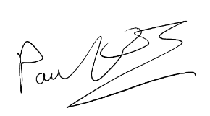
Sir Paul Ennals, Chairman
Date: 26 September 2025

Footnotes

https://www.newcastle-hospitals.nhs.uk/wp-content/uploads/2024/06/Climate-strategy-2020-2025.pdf
https://racetozero.unfccc.int/system/race-to-zero/
https://www.smartcarboncalculator.com/
https://www.gov.uk/government/collections/government-conversion-factors-for-company-reporting
https://www.england.nhs.uk/greenernhs/a-net-zero-nhs/
https://ghgprotocol.org/corporate-standard
https://ghgprotocol.org/standards/scope-3-standard
https://ghgprotocol.org/scope-3-calculation-guidance-2
https://www.gov.uk/government/publications/environmental-reporting-guidelines-including-mandatory-greenhouse-gas-emissions-reporting-guidance
https://www.newcastle-hospitals.nhs.uk/about/sustainable-healthcare/shine-annual-reports/
https://www.england.nhs.uk/greenernhs/a-net-zero-nhs/
In our baseline year we estimated emissions associated with our purchased goods and services (scope 3 Category 1/NHS Footprint Plus) using a spend based method. In 2023-24 we calculated these emissions using the Greenhouse Protocol hybrid method (40% of our emissions were reported directly from suppliers; 60% were estimated using a spend based method). This has resulted in a significant increase in our scope 3 emissions and so we will need to recalculate our Scope 3, or NHS Carbon footprint plus, baseline.
https://www.newcastle-hospitals.nhs.uk/about/sustainable-healthcare/shine-annual-reports/
https://www.newcastle-hospitals.nhs.uk/about/sustainable-healthcare/sustainable-suppliers/
https://ghgprotocol.org/corporate-standard
https://www.gov.uk/government/collections/government-conversion-factors-for-company-reporting
https://ghgprotocol.org/standards/scope-3-standard

